Chapter 10, Problem 62.

Using Thevenin's theorem, find v_{o} in the circuit in Fig. 10.105.

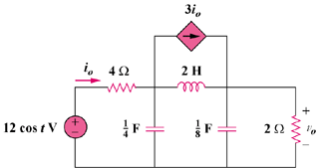

Figure 10.105
For Prob. 10.62.

